Study Guide
Ancient Rome
1. In what ways did Roman law and religion influence daily life? List as many as you can.
2. What were the roles of men, women, and children within Roman
families?
Family Member | Responsibilities

How did food and drink, housing, and education differ for people of dif-
ferent social classes?
Poor Wealthy
Food & Drink
Housing
Education
In what ways was life in the country similar to life within the city of
Rome? In what ways was it different?
What role did slavery play in Rome?
In what ways did the Greeks influence Roman society? Create your own graphic organizer to explain.
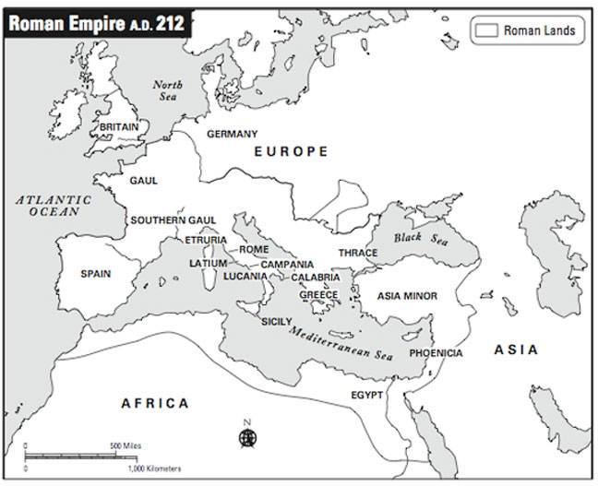
1. Put a star on Rome.
2. Color the Roman empire red.
3. Color the Mediterranean Sea blue.
4. Label the Nile River and the Red Sea.
5. Put a black circle around Greece and its surrounding islands.
6. Label the two natural borders that stopped Roman expansion in the north and south.
7. Draw a line of the route Romans might have taken to get to Britain by sea and by land.

