Choose from the following activities to complete in your notebook. Whatever activity you choose, you must focus on how Rome was influenced by Greek cultures, and highlight the factual information.
Choice #1: Write a magazine article/news report with an image with the following heading,
“Rome Copycats Greece!”
Choice #2: Create blueprints (drawings) of a museum exhibit that displays artifacts from Rome. Draw an object from each area of life (engineering, sports, architecture, writing, art, mythology), then add a caption sign with information about it. You may even create a layout of your museum!
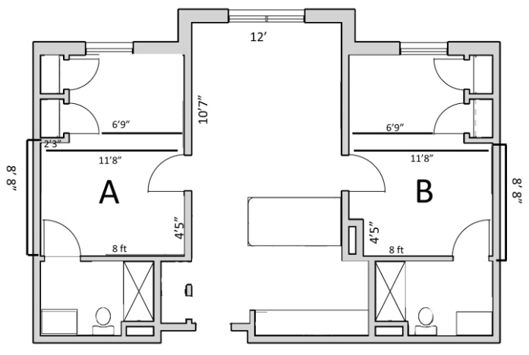
Choice #3: Write at least 3 journal entries from each viewpoint of two different people in Rome: a gladiator and a Roman citizen that is planning to attend the sporting events. Include at least one “photograph” from the event.
January 4, 745 B.C.E.
I have found out who my next fight will be against and so has my brother, for we are to be fighting each other! I cannot stand the thought of it! By the end of the fight one of us will have lost everything we hold dear, for if we do not have one another, we have no one. The fight is tomorrow and I dread the coming of the dawn. To say…
‘We are about to die” next to my brother will be torture, because when it comes down to it, one of us will be dead by the time the sun sets tomorrow.
Marcus

