DIVERGENT BOUNDARIES: Continental-Continental
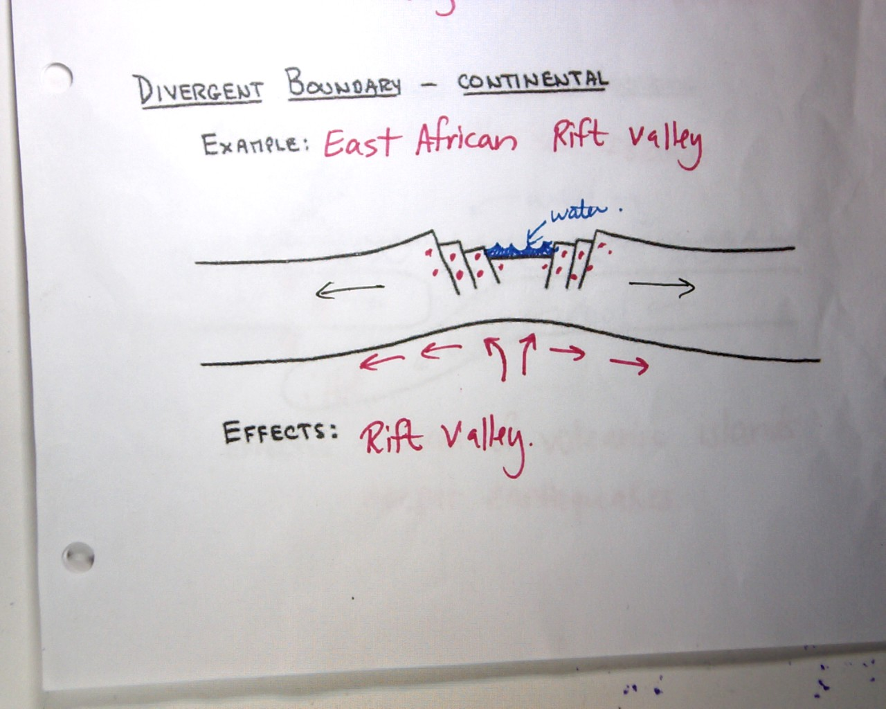

DIVERGENT BOUNDARIES: Oceanic-oceanic
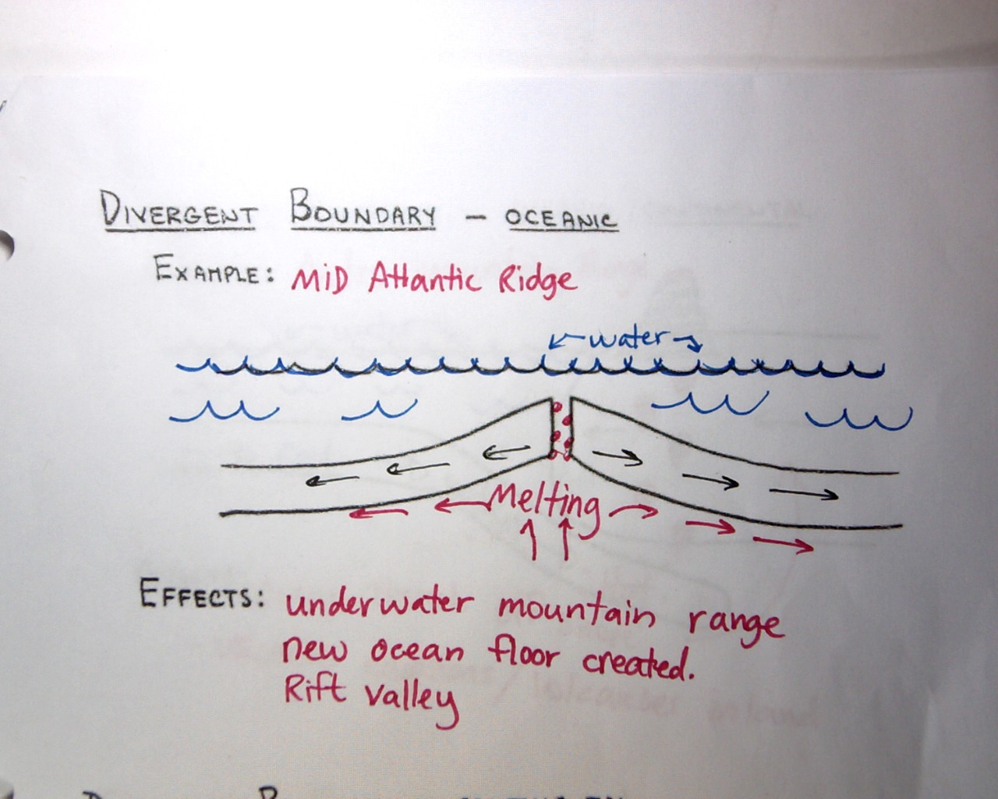

CONVERGENT BOUNDARIES: Continental-Continental
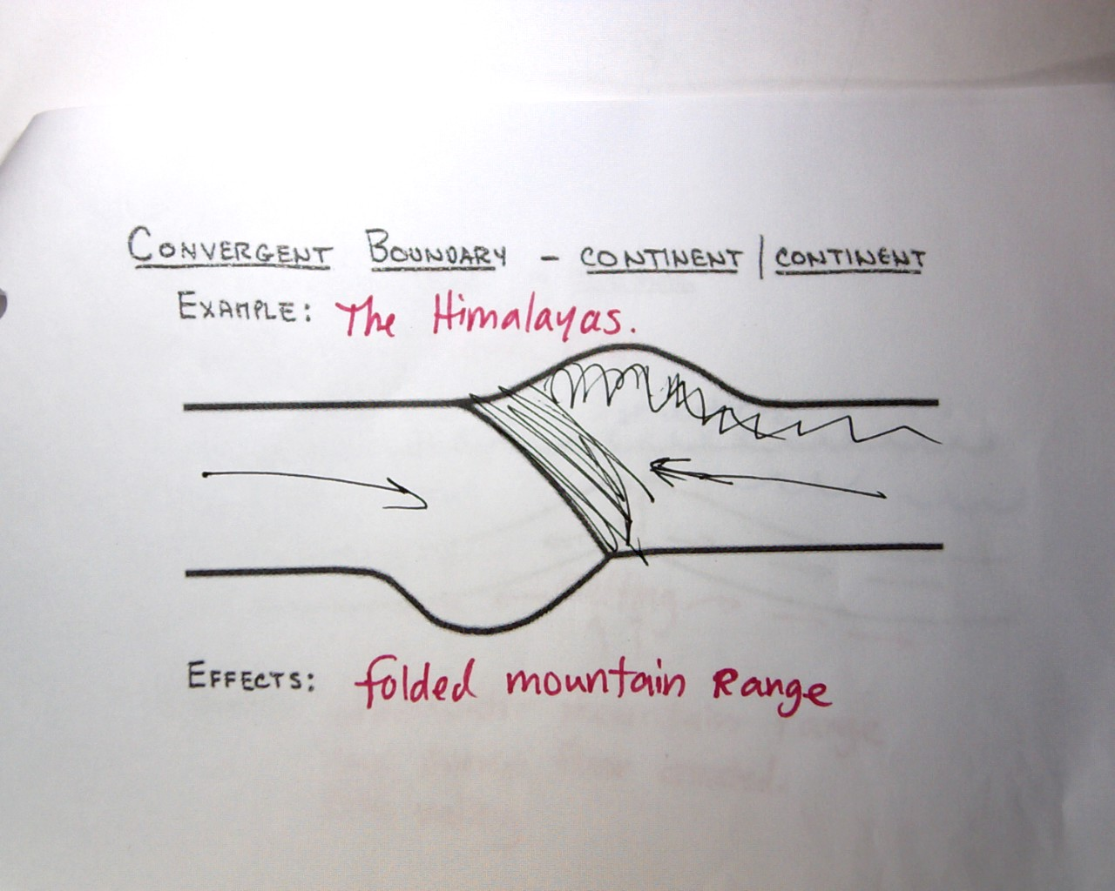

CONVERGENT BOUNDARIES: Continental-Oceanic
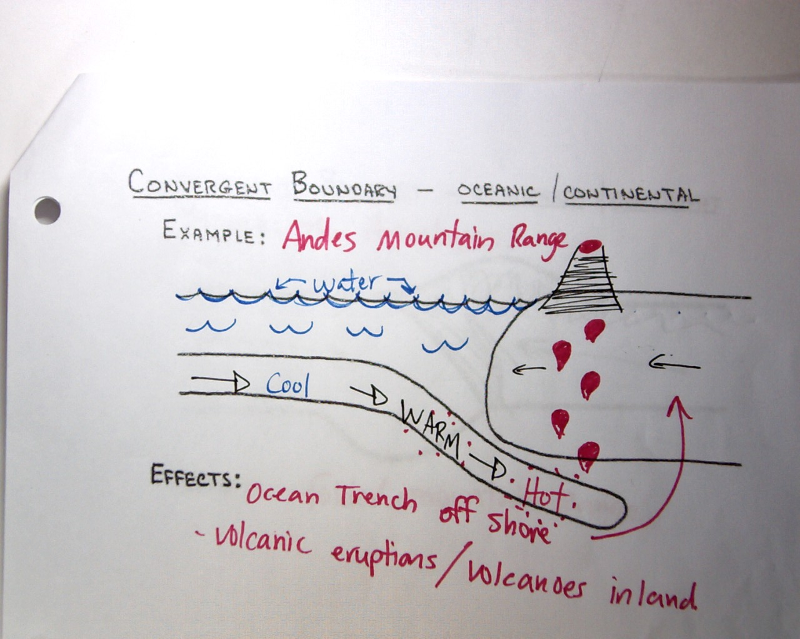

CONTINENTAL BOUNDARIES: Oceanic-Oceanic
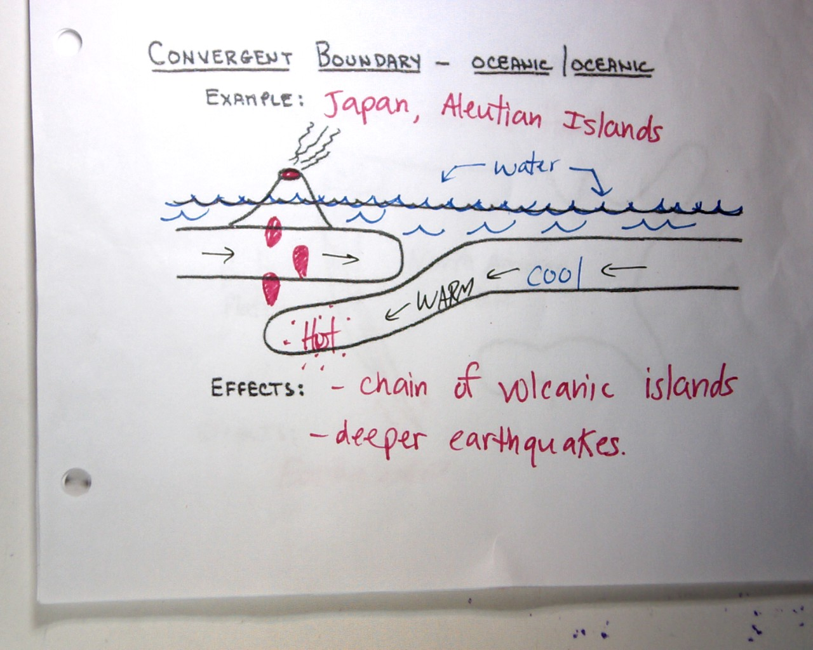

TRANSFORM BOUNDARIES: Continental-continental
