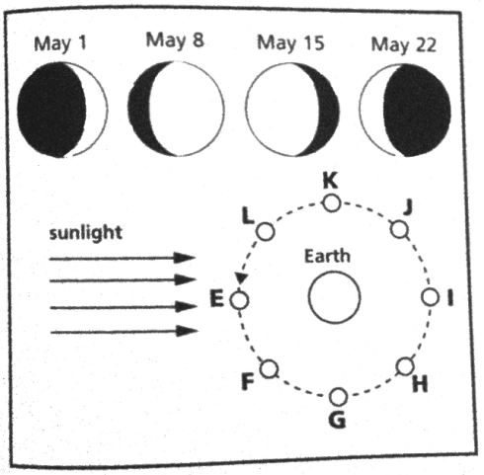
DIRECTIONS: Print out this sheet and complete, or write the answers on a separate sheet of paper. Use Animation #2 on the website to help you, if necessary.
1. About how long does it take the Moon to revolve once around the Earth?
2. Why is just one side of the Moon (lit or dark) visible from Earth at any time?
3. What phase is the moon in when Earthlings are facing the “dark side of the moon”?
4. Why does the Moon seem to change shape?
5. Explain why the moon can be visible during the day.
Use the following diagram to answer the questions below.
6. At which letter on the diagram might a full moon occur?
7. Which letter on the diagram shows the position of the moon on May 8th?
8. Approximately when was the moon full?
A. May 4
B. May 11
C. May 18
D. May 29
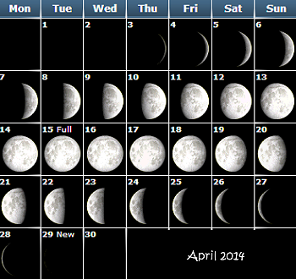
9. Label the 8 phases as they occurred for this April 2014 lunar calendar by writing the date each phase began. Remember that each phase lasts for approximately 3.5 days!
New Moon: ______________________
Waxing Crescent: _________________
First Quarter: ____________________
Waxing Gibbous: _________________
Full Moon: ______________________
Waning Gibbous: _________________
Third Quarter: ___________________
Waning Crescent: ________________
10. Why did the new moon last for so many days?_________________________________________
______________________________________________
______________________________________________

