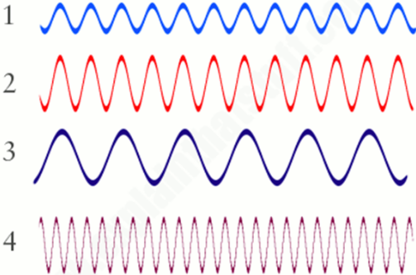
What are the qualities of each wave? Use your notes if you need to!
- Which wave has the lowest amplitude?
- Which wave has the highest amplitude?
- Which wave has the longest wavelength?
- Which wave has the shortest wavelength?
- Which wave would have the highest pitch?
- Which wave would have the lowest pitch?
- Which wave has the highest frequency?
- Which wave has the lowest frequency?
Can you order the waves? Use your notes if you need to!
1. Highest pitch to lowest pitch?
2. Lowest frequency to highest frequency?
3. Longest wavelength to shortest frequency?
4. Highest amplitude to lowest amplitude?

